Volunteers’ Management System
Final Report
Industrial Challenge Project Course

Apollo Group

Content
1 Introduction 3
1.1 Purpose 3
1.2 Definitions 3
2 Background 3
2.1 Problem Description 3
2.2 Solution: Volunteer Management System (VMS) 4
2.3 Alternating systems and researches 5
3 Features 6
4 Requirements 8
4.1 Requirement Traceability 8
4.2 Functional Requirements 8
4.2.1 Overall Use Case Diagram 9
4.2.2 Important Use Cases 9
4.2.3 Screen Mockups 14
4.2.4 Other Functional Requirements 17
4.3 Non Functional Requirements 17
5 System Architecture 18
5.1 Architectural Goals and Constraints 18
5.2 Architectural Overview 18
6 Summary 19

Introduction

Purpose
This document is prepared to explain main characteristics of Volunteer Management System.
After an introduction with problem description and an overview of our proposed solution, VMS, we continue by explaining features and requirements. In order to avoid any confusion by detailed explanations, only key requirements are included and others are only listed with their references to related project artifacts. At the end of the document, to show the feasibility of this project, we introduce a candidate architecture that can achieve the desired features.

Definitions
Citizen: General public.
Volunteer: Any person who uses VMS client /Mobile Application to help in crisis situations.
Crisis: Disasters that interrupts normal life
Incident: Unexpected and non-routine event that can cause trouble to the human beings normal day to day life, in VMS these incidents will be registered under a crisis. Collapsed buildings and fires are some examples.
Crisis Manager: Person at the humanitarian organization who uses VMS to manage a crisis
Crisis Management Center: The place where the crisis is managed by VMS.
Help Request: A question that is directed to the volunteer by the system. It asks for individual help or providing some material.

Background

Problem Description
World is always having disasters and crises. Earthquakes, hurricanes, terror attacks or wars are some of examples we witnessed recently. Many people die and many of them lost. The normal city life is corrupted. Even after the crisis, problems remain as epidemic or starvation.
To overcome all challenges of crises, there are many kinds of organizations whose main aim is to help people to overcome those crises. Militaries, civil defense organizations, international help organizations are some examples of them.
While some of those organizations such as militaries are active just in crisis times, some others try to put precautions to lessen the effects of those crises.
When we analyze the common characteristics of help organizations, we see that they are facilitating with their trained members. Militaries have educated soldiers, Red Cross has members with certificated training and Civil Defense in Sweden has hired experts.
For a regular citizen, it is difficult to join any of such organizations. It requires completing some training programs and then continuing to attend regular meetings. Moreover, some of them require membership payment. Their organizational structure is not built on regular citizens but their educated, active members.
Beyond the difficulties for being a member of help organizations, there is another obstacle. People don’t want to be a member of such organizations. Unless they faced to a crisis just near them, they are not so eager to join those help organizations like Civil Defense or Red Cross. However, when they live a crisis, if they have the opportunity, most of them want to help other people who are in difficulty.
The problem is that; help organizations miss out regular citizens who can assist them in crisis time. Help organizations form their structure before the crisis happens. However, people don’t or can’t join these organizations before crisis time. People only consider joining help organizations if there is a crisis but there is currently no quick way for this.
Ad de Raad, UN Volunteers Executive Coordinator, emphasizes the problem clearly in the World Conference on Disaster Reduction in Japan, 1995: “In the wake of disasters, we have seen repeatedly how considerably large numbers of generally unskilled, untrained, and unaffiliated citizens are mobilized through volunteerism to lend a hand. However, much of it is ad hoc and uncoordinated. At best, this can result in a considerable loss of effectiveness. At worst, undirected volunteers can become part of the problem in a disaster situation.”
If we imagine a city wide earthquake that 40% of all citizens die, 20% are under wreck and remaining 40% is fine, then we can assume that, at least 10% of all city population can help rescue operations. For a small city of 100.000 populations, that means 10.000 people. Even if a so small portion of them willing to attend help facilities, that size would be great, many times greater than all of help organizations in that city.
If there is a system that allows people to join help facilities not only before crisis but also after a crisis happens, and that enables crisis manager to manage that huge amount of people effectively, it would be a great solution.

Solution: Volunteer Management System (VMS)
VMS is a revolutionary solution that establishes a bridge between help organizations and volunteers in crisis times. It is based on the idea that: people consider helping others when there is a crisis. VMS provides a quick and easy way to attend the help facilities and help crisis manager to organize thousands of volunteers in any crisis efficiently and effectively.
Infrastructural Overview
VMS is a composite software solution that includes a central web portal to manage a crisis and a mobile application as an interaction channel for volunteers. Figure 1 visualizes the functionality of the system.
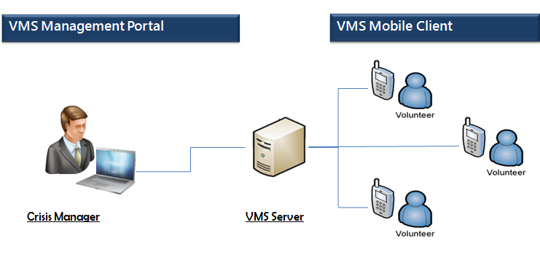
Figure 1: Functionality of VMS
After a crisis happens, volunteers install VMS mobile client and register to the VMS. On the other side, crisis manager defines the problems, in VMS context, incidents, with all the resources defined. Then system helps the manager gathering the required resources.

Alternating systems and researches
There are several researches and systems that aim managing volunteers. Not all of them target disasters. There are other kinds of volunteer management systems as well, such as volunteering for children education or nature protection. Among the disaster related ones, most of them focus on crisis preparedness which consists of gathering and organizing volunteer information prior to any crisis. Besides, there are well defined structures and systems for crisis response like NIMM consistent ACPH-VMS but they are only procedures and there was not any software system to support these procedures. Of the very few volunteer management systems that are active in crisis time, we have not found any product which provides an interface for the volunteers.
In recent years, developing technology contributed much to the efforts of developing disaster related software. Sahana is considered as the most significant project. It has many different modules such as volunteer management module or request/aid management module. However it lacks mobile application functionalities. All of the interfaces of Sahana are reached via web browser and main functionalities consist of information gathering and resource management such as aids. Thus manpower of volunteers is not considered in the context of Sahana. There is one ongoing mobile application development, but it is not mature yet and it only covers filling some forms for information gathering.
As a conclusion, none of the alternating volunteer management systems provides similar functionalities to our solution. None of them have mobile end which provides two sided communication channel and enables crisis manager to organize volunteers to solve incidents easily.

Features
Different problems in the current situation are identified and corresponding features are determined. Below, we listed main problems and business goals with corresponding feature of VMS.
Problem 1
In the wake of disasters, large numbers of people want to attend help facilities. They could be easily become a part of the system.
Feature: Easy registration at crisis time
Citizens can register to the system at the time of a crisis or before the crisis. Registration can be only for short term that is the user can be part of the rescue organization only at the crisis time. Registration procedure requires some basic information about the members and gives user name and password for subsequent logging into VMS. By having authenticity in the login and also by having different users like manger and volunteers, VMS is secured.

Problem 2
There are both skilled and unskilled volunteers. They should be differentiated.
Feature: Profile Management
System keeps tracks of all the information about the members including their personal information, education or experience. Members at any point of time can add or modify this; subsequently the system adjusts to the current available list.

Problem 3
For a large number of volunteers registered to the system, assigning tasks to them and organizing them for help facilities can be impossible.
Feature: Resource Management
Volunteers and other resources can be managed easily by the managers. This feature is semi-automatic. VMS intensively assists the crisis manager for resource management at the time of crisis by helping in selecting the volunteers according to region, type of the crisis, etc. VMS assists Manager heavily based the crisis nature and severity of the crisis.

Problem 4
There can be many different problems in the crisis area, therefore, organizing the information of different problems and managing them is troublesome.
Feature: Incident Management
Any number of incidents can be managed by system. System behaves differently to the different incidents. There can be different needs, different resource assignments and also different states like active or resolved. All the incidents are visualized on an interactive map, thus providing an easy management. VMS also assists the crisis manger in handling resources according to the nature of incidents.

Problem 5
In the big disasters, police or other official information sources can be insufficient for getting information
Feature: Information Gathering
Volunteer can be used as an information source for new incidents and also for status of the existing incidents. Volunteers can report new incidents or the progress of existing incidents with video or picture support.

Requirements

Requirement Traceability
To achieve desired features, some high level requirements are identified. Here is the trace information of high level requirements.
ID | Description | Source | Validation | Priority
REQ01 | Manage crisis items and incidents inside | Features: Incident management | By customer | 3
REQ02 | Manage requests for stuffs and volunteers for each incident | Features: Resource management, Communication | By customer | 1
REQ03 | User registration in the system and managing profile | Features: Registration and membership, Profile management | By customer | 6
REQ04 | User login to the system | Features: Registration and membership | By customer | 6
REQ05 | Manage statistical reports from available crisis data | Features: Log analysis and backup | By customer | 5
REQ06 | Manage reports by citizen side | Features: Information gathering, Communication | By customer | 4
REQ07 | Managing alerts to citizens. | Features: Resource management, Communication | By customer | 8
REQ08 | Searching volunteers based on their profile information | Features: Resource management | By customer | 2
REQ09 | Data backup | Features: Log analysis and backup | By customer | 7

This set of high level requirements are addressed and detailed by a list of use-cases some of which are given in section 4.2.2. Each use case supports one or more requirements which is specified in above table.

Functional Requirements
Functional requirements of VMS system are defined in use-case format as details of requirements. Here you can find overall use case diagram and later important use cases. All of the use cases can be found in Software Requirement Specification Document.

Overall Use Case Diagram
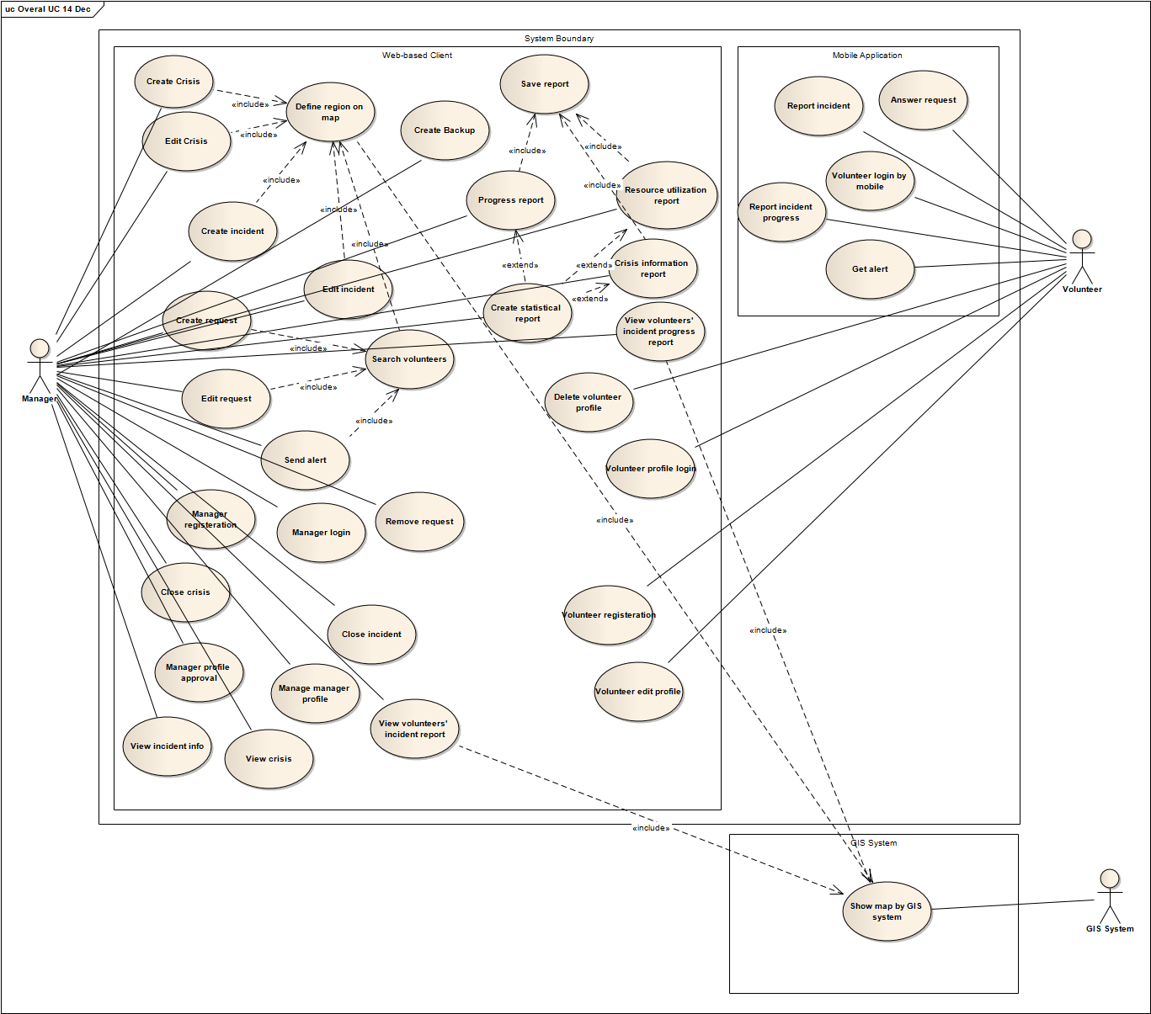

Important Use Cases

Create Crisis
Use Case Name | Create Crisis
Description | Manager defines a new crisis in the system.
Actors | Manager
Identifier | UC 01
Traceability | Req01
Pre-conditions
- Manager should be logged in.
- There is no active crisis in the system.
- Crisis Management main page is opened
Post-conditions
- A new crisis is created. System is ready to work on it.
- The data and actions are logged in the system.
R01-1 Main Path
- Manager selects “Create new crisis” menu
- System shows new Crisis Information Page containing the map.
- Manager fills the form and saves:
Selects type of the crisis from a list.
Enters the crisis name.
Defines the crisis and area on the map refer to Define Region on map use-case
Enters information in message box
Presses save button
- System validates the data and saves the information and navigates to Crisis Management main page.
Alternate Paths
R01-2
In step 4, the system finds that some data are invalid and shows a message to Manager about the problems in data. Workflow goes to step 3.
R01-3
In step 3, Manager presses ‘Cancel’ button. Then system ignores all data entered and navigates to Crisis Management main page.
Non-Functional

Issues
Only one crisis can exist at a given time.

Create Incident
Use Case Name | Create Incident
Description | Manager defines a new incident in the system including resources needed for that incident.
Actors | Manager
Identifier | UC 04
Traceability | Req01
Pre-conditions
- Manager should be logged in.
- There is an active crisis in the system
- Crisis Management main page is opened
Post-conditions
- A new incident with needed resources for that is defined and crisis map is updated
- The data and actions are logged in the system.
R04-1 Main Path
- Manager selects “Create incident” menu
- System shows New Incident Page containing a map
- Manager fills the form:
Defines the incident and resources area on the map refer to Define Region on map use-case
Selects the type of the incident from the incident type list(with predefined values as building collapsed etc)
Enters the Incident name
Enters explanation of incident
Selects the severity (Critical/Serious/Normal/Moderate/Minor)
Selects the priority(High/Medium/Low)
Defines the resources need list by entering type of need, amount and units for that need.
Presses the OK button
- System validates the data in the form, saves the information, navigates to Crisis Management main page and updates the crisis map.
Alternate paths
R04-2
In step 4, the system finds that some data are invalid and shows a message to Manager about the problems in data. Workflow goes to step 3.
R04-3
In step 3, Manager selects ‘Cancel’ button. Then system ignores all data entered and navigates to Crisis Management main page
Non-Functional
Issues

Create Request
Use Case Name | Create Request
Description | Manager creates and sends a request related to an active incident.
Actors | Manager
Identifier | UC 06
Traceability | Req02
Pre-conditions
- There is an active incident
- Crisis Management main page is opened
Post-conditions
- Automatic request sending is started.
- The data and actions are logged in the system.
R06-1 Main Path
- Manager finds volunteer refer to Search Volunteers use-case
And selects the incident from the list of incidents
- System shows information and options for the incident
- Manager selects “Create Request” option
- System shows Create Request Page
- Manager fills the form and sends request:
Enters a message to the volunteers
Presses ‘Send request’ button.
- System saves and sends the Manager’s massage with the incident need list, incident location to the Mobile Application and navigates to Crisis Management main page.
Alternate paths
R06-2
In step 5, Manager presses the ‘Cancel’ button. Then system ignores this dialog and returns to Crisis Management main page.
Non-Functional
Issues

Answer Request
Use Case Name | Answer Request
Description | Volunteer receives a request on Mobile Application and responds to it.
Actors | Volunteer
Identifier | UC 08
Traceability | Req02
Pre-conditions
- Volunteer is logged in to the system by Mobile Application
- Volunteer has a new request
- Mobile Application main page is opened
Post-conditions
- System updates resource need list
- The data and actions are logged in the system.
R08-1 Main Path
- Volunteer selects the request
- Mobile Application shows Request information
Shows Manager’s message
Shows location of incident
Shows need list (type, amount and unit).
- Volunteer reads the request message with need list.
Volunteer enters the amount he/she can provide by filling amount row and presses the ‘Accept’ button.
- System registers the data, saves it and recalculates the amount of needs according to entered resources and navigates to Mobile Application main page.
Alternate paths
R08-2
In step 3, Volunteer presses ‘Reject’ button. Then system updates his/her request as rejected in the system and navigates to Mobile Application main page.
R08-3
Volunteer doesn’t take any action on that request neither accepts nor rejects. System waits for 10 minutes (from the time of sending the request) and then assumes the request as rejected.
Non-Functional
Issues

Volunteer Registration
Use Case Name | Volunteer Registration
Description | Volunteer registers by web application
Actors | Volunteer
Identifier | UC 12
Traceability | Req03
Pre-conditions
- Crisis Management Login page is opened
Post-conditions
- Volunteer is registered and automatically logged into the system.
- The registration detail of the new Volunteer is logged in the system.
R12-1 Main Path
- Volunteer selects ‘Volunteer’ as user type (Manager/Volunteer) and selects “Register” menu from Login page
- System shows Volunteers Registration page
- Volunteer enters required information and registers
Name, last name
Age, gender, address
phone, job, email address
Height, weight
Education
Special training
Any health problem
Country
City
Selects username and password
Presses Register button
- System registers new Volunteer and opens Volunteer’s profile page
Alternate paths
R12-2
In the step 4, application warns about incorrect data, incorrect username and/or password. Workflow goes to step 3
R12-3
In step 3, volunteer selects ‘Cancel’ button. Then system ignores all data entered and navigates to Login page.
Non-Functional
Issues

Report Incident
Use Case Name | Report Incident
Description | Volunteers reports about incident through Mobile Application
Actors | Volunteer
Identifier | UC 15
Traceability | Req06
Pre-conditions
- Volunteer is logged in to system by Mobile Application
- Mobile Application main page is opened
Post-conditions
- Incident report is saved in the system
- The data and actions are logged in the system.
R15-1 Main Path
- Volunteer selects 'Report Incident' menu
- Mobile Application shows ‘Report Incident' page
- Volunteer fills the report form:
Location of Incident in text
Type of incident
Enters message for Manager
Presses 'Send' button
- Mobile Application validates the data entered, sends the report to the system and navigates to Mobile Application main page.
Alternate paths
R15-2
In step 3, Volunteer selects 'Cancel' button. Mobile Application discards all information and navigates to Mobile Application main page
R15-3
In step 4, Mobile Application verifies missing data and inform volunteer. Flows go to step 3
R15-4
In Step 3, Volunteer presses 'Photo' button
Mobile Application navigates to Picture page.
Volunteer presses 'Take Picture' button
Mobile Application takes picture, adds to the volunteer’s report and automatically returns to Report Incident page. Flows go to step 3.
R15-5
In Step 3, Volunteer presses 'Video' button
Mobile Application navigates to ‘Video’ page.
Volunteer presses and holds Record button
Mobile Application records the video
Volunteer releases the pressed button
Mobile Application stops the recording, adds the video to the volunteer’s report and automatically returns to Report Incident page. Flows go to step 3.
Non-Functional
Issues

Screen Mockups
Some important screen mockups are given below to illustrate the functionality expressed in use cases.
UC01-Create Crisis & UC02-Edit Crisis
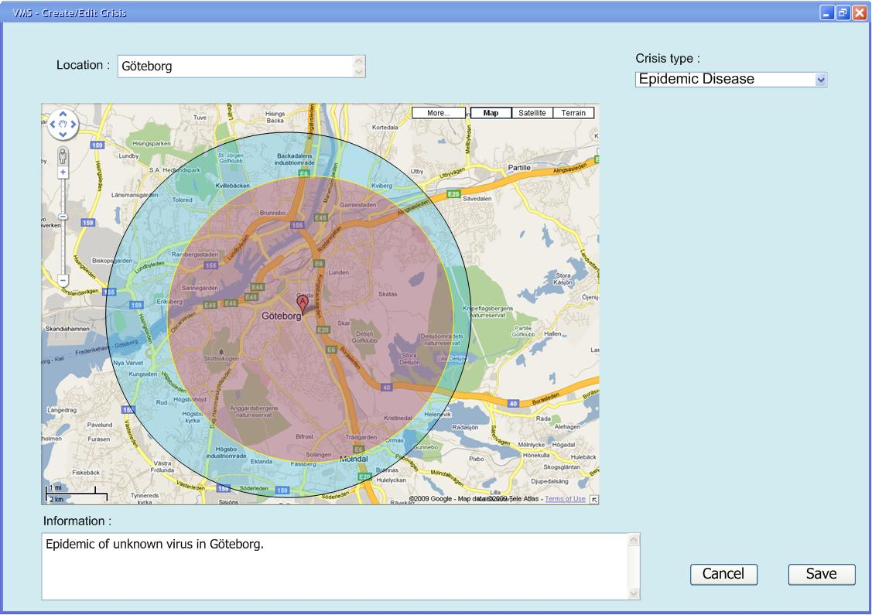
UC04-Create Incident & UC05-Edit Incident
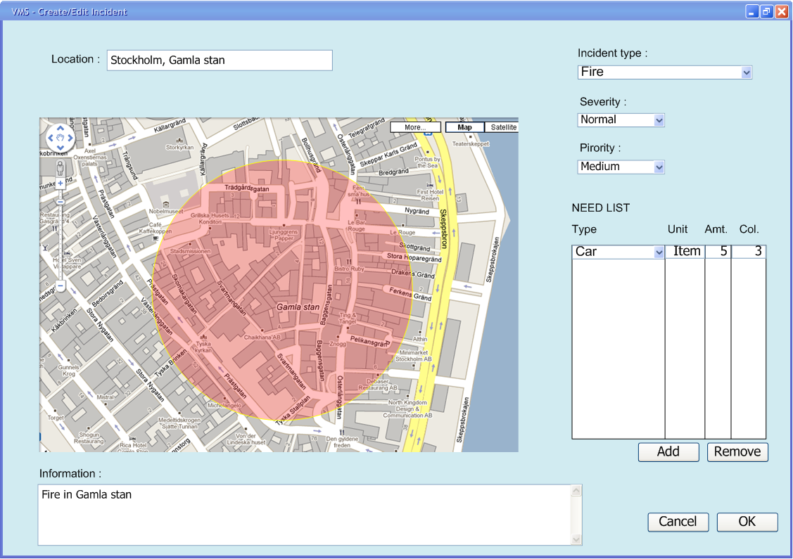
UC06-Create Request & UC07-Edit Request
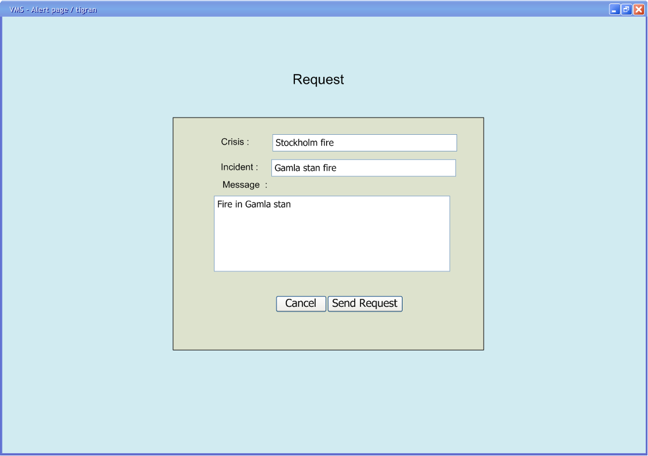

UC08-Answer Request
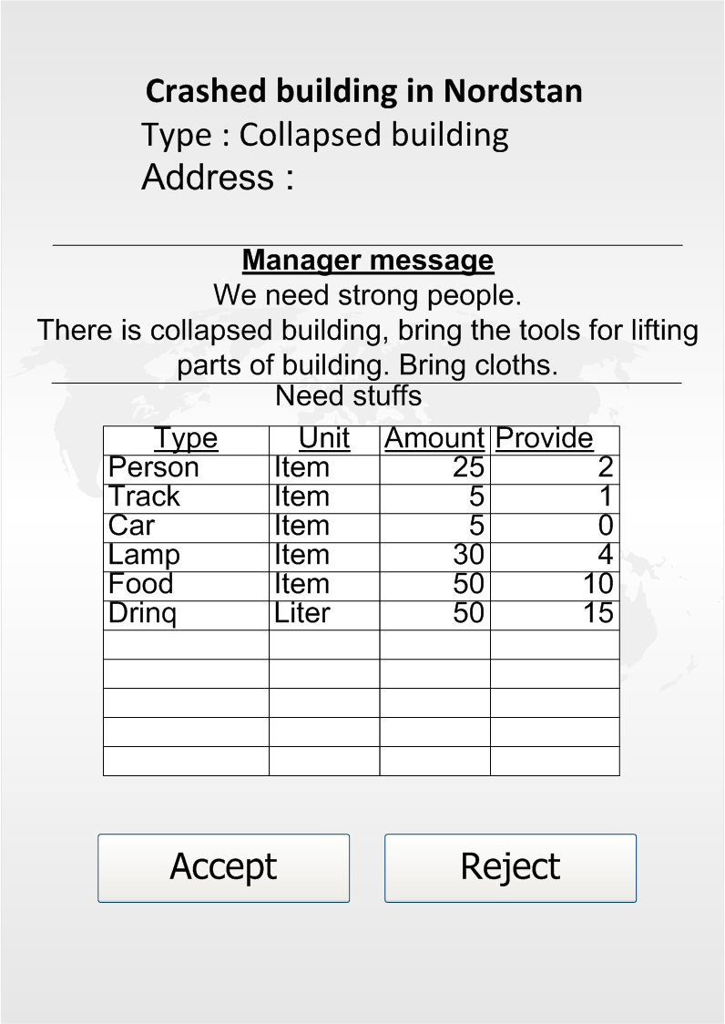
UC15- Report Incident
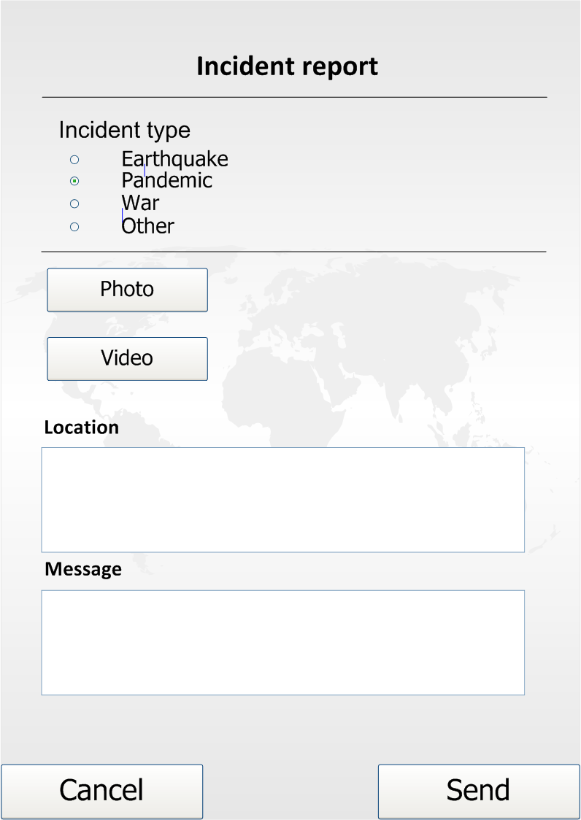
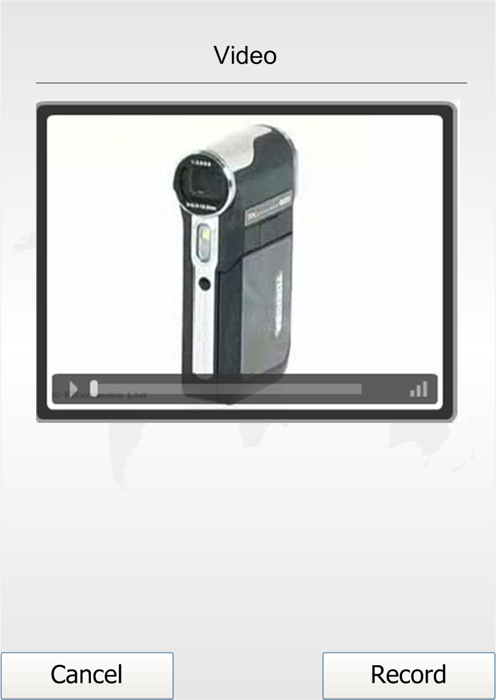

Other Functional Requirements
Automatic Request Sending
It’s a unique type of requirements for VMS. Any request which will be send by Manger will have request message, need list, location and so on. VMS Manger will initially create this kind of request with the help of VMS system by creating incident, subsequently by creating need list for those incidents, and then by selecting the required volunteers and finally manger will send this request to the selected list of volunteers.
Each request message has predefined set of time out period, after that if the VMS has not got the sufficient number of volunteers or resources for an incident, then the system will automatically selects and sends request for anther additional set of volunteers for help with the updated need list. Suppose that some volunteers may reject or some may not reply since they are not willing to participate in the rescue operation, in that case VMS needs additional volunteers or resources, this will be accomplished by triggering automatic request resending option by the system after the timeout period of the request if the need list is not complete.

Non Functional Requirements
Non-functional requirements are defined in Supplementary Specification Document. Here, we listed some important ones.
Interoperability
- The data which is provided by this system could be useful for other crisis systems, thus there must be defined data gates that can be used. These data gates will follow XML1.0 standard for their outputs.
Usability
- As the volunteer’s client side of the system is based on mobile phones, it should have minimum interactions needed to use a function. Though it’s considered that no function of the mobile client application has to take more than 5 steps to be used, and average of the number of steps for all functions should not be more than 3 steps.
- As the manager’s client side of the system is web-based and according to the amount of tasks which should be managed by managers, it’s considered that no function of the web-based client of the system has to take more than 7 steps.
Installability
- Server side of the system should be installable package, which will be installed in less than 2 hours considering all configurations needed. Configuration of the server side will not be manually performed; all the configurations should be performed with the help of automatic wizard-based application
- The mobile client of the system should have the ability to be installed without any manual configuration within 15 minutes.
Fault tolerance
- VMS System should be available to volunteers at least 99% of time during the crisis. Availability is negotiable after/before crisis time.

System Architecture

Architectural Goals and Constraints
The followings are some of the major software requirements and objectives that have a significant impact on the VMS software architecture.
- Use of Google Map GIS System services in web-based client
- Use of Java as client application on mobile phones, takes into an account of quality criteria specified in supplementary specification document.
- Connection between mobile clients and the server through 3G, GPRS, and/or WLAN
- Use of web-based client application for Manager’s side which is based on HTML 4.0, takes into an account of quality criteria specified in supplementary specification document.
- Use of architectural and design patterns like facade, takes into an account of maintainability criteria specified in supplementary specification document.
- Use of XML 1.0 as the standard for data output gates for the system takes into an account of quality criteria specified in supplementary specification document.
- Use of service-oriented architecture as the nature of project needs this architecture.

Architectural Overview
Overall architecture of the system consists of the following layers. The detailed explanation can be found in System Architecture Document.
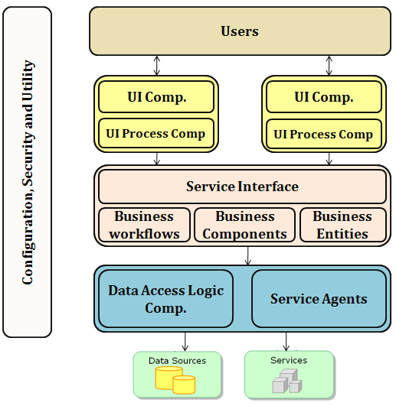
Figure 2 Overall Architectural Diagram

Summary

Disasters will exist as a threat to the entire world. All the people should corporate to solve the difficulties caused by disasters. Many organizations all over the world are trying to establish a good structure and a good system to achieve that corporation.
Apart from the professional workforce of those organizations that aims helping people, volunteerism is a missed out source of resource. Very large numbers of citizens become volunteers in disaster times. If they are organized and directed well, success of the help organizations would be boosted. Unfortunately, none of the existing systems has achieved the desired utilization of volunteers in disaster times.
VMS is a pioneer solution as it provides an efficient and effective utilization of just-in-time volunteers. It differs from alternates by reaching its users via mobile phones which are the most common devices in today’s world.
With the help of semi-automatic requesting feature of VMS, thousands of volunteers can be organized and directed to different incidents. Thus, damages of disasters can be reduced drastically and any chaos caused by unorganized volunteers can be prevented.

Revision History
Date | Name | Work | Version
2009/12/20 | All members |  | 1.0
2010/2/1 | Abdullah Arslan  Mustafa Al-Zubaidi  Waseem Soomro | Updated according to the feedback | 2.0

http://www.unv.org/en/current-highlight/focus-on-emergency-relief/doc/volunteers-vital-before-and.html
http://www.gwu.edu/~icdrm/projects/VMS/index.htm
http://wiki.sahana.lk/doku.php/dev:j2meclient

